Understanding our data – Checking for missing data, duplicates or errors – this check is for table 1 ‘Data’
- Created a table, checked for each dropdown where I expect unique values and certain values.
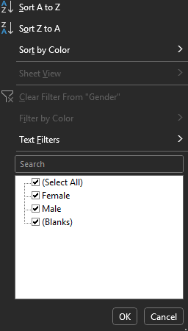
Columns checked:
Name: need a different way to look for dupes for that.
Department has all unique names, no variations on spelling of departments.
Checked age: ranges from 19-46 so no underaged workers or people
Salary looks fine and rating has no duplicates

Gender drop down shows that there are blanks in that column that need dealing with.

Below are all the rows that have blank genders
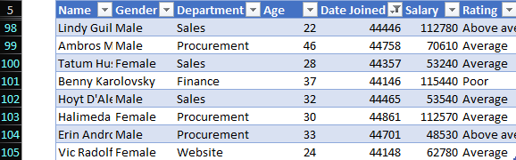
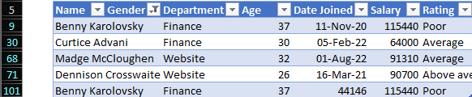
Gender and date incorrect (benny)

As Excel defaults to 44XYZ dates if you don’t date format them – excel calendar begins from 01.01.1900 and the value if like 45000 means 45000 days since the calendar started. Simply change this to date format.

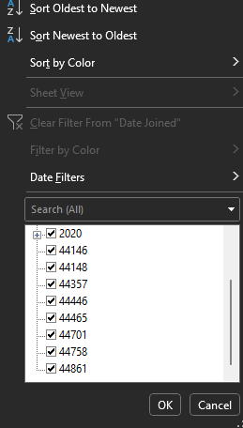
Rows that have issue with the date being formatted incorrectly
Dates converted to dd-mmm-yy and all are standard now.



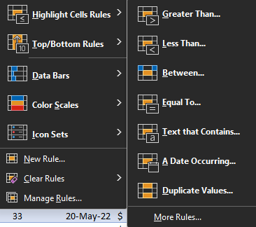
Check for duplicate names:

Sample screenshot of duplicate names identified
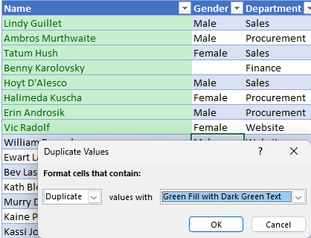
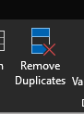

The above steps were done on table 1 (New Zealand employees) and these steps were taken again on the second table (India staff) to identify any errors there.
Created a table, checked for each dropdown where I expect unique values and certain values.
All columns have no duplicates from basic check, but gender has issues with blank data.
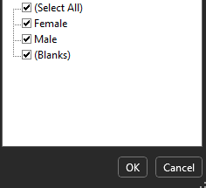

Below are all the rows that have issues with gender being blank

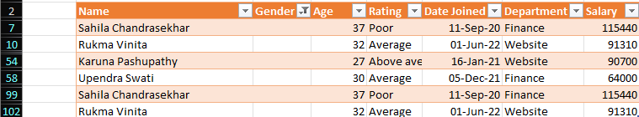

Power Query – Table tweaks
Adding new column in power query for both tables to allow us to differentiate when the tables are combined
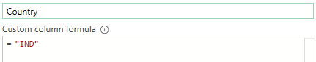
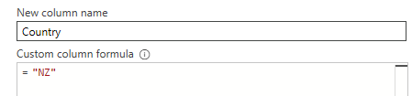

Consolidating data, changing column order
‘Appendic Operation’
Similar column structures so append together
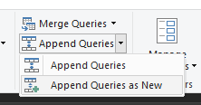
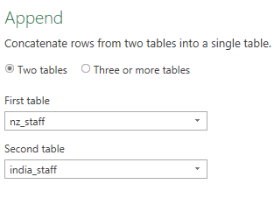
Tables combined and now we have our data set to understand, standardize, clean and analyse.

Dealing with duplicate names:
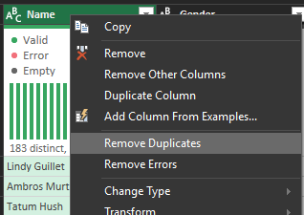

First occurrence will be kept, and any future ones will go. As this is a small dataset, I am comfortable doing it here as this example takes the assumption that names have been duplicated and are not a different member of staff. However, for large data sets where duplicate names could be 2 different people, it is not a good idea as customers could be removed.
If it was a large data set and I wasn’t able to take liberties with assumptions, using a unique key e.g, employee ID, customer ID, would be a better way to remove duplicates.

Dealing with null values in gender:
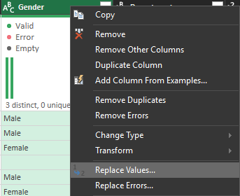

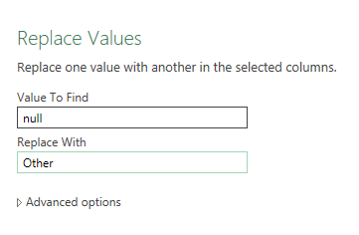
All null values are now ‘other’ for future data.

Data loaded as a connection:
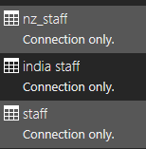
Time to make new table to analyse.

Loading data from connections:
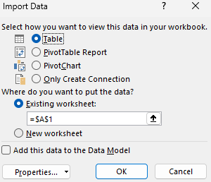

Next steps:
- Quick analyse (basic questions)
- Informaton finder – easy way ot find all info about any employee
- Extended information finder – e,g, find all employees info in departments
- Male vs female comparison
- Calculate annual bonus – bonus calculator

- Basic understanding to give us some general statistics to understand our employees better
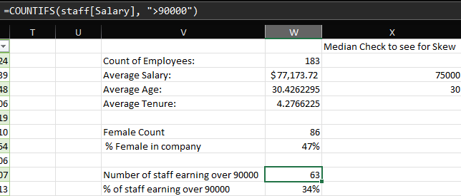

- Basic Information Finder:
XLOOKUP
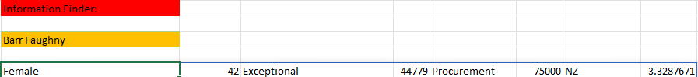
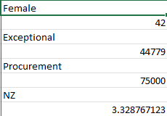
The above puts the information into a table that is easier to understand. Depends which way you want the data to run (down may be easier)
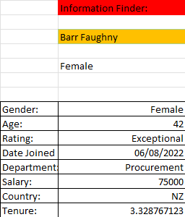
Cleaned/easier to read version
This is dynamic but still not ideal as you have to type the name each time

- Addition to information finder

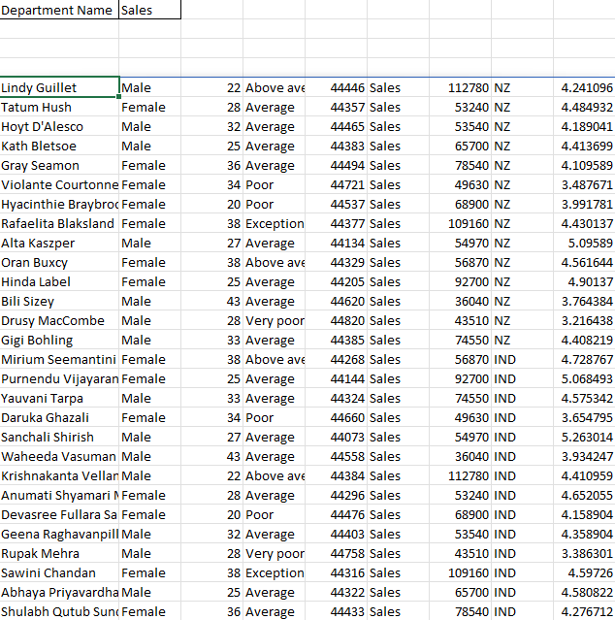
This gave us the entire sales table row for each person in the sales category. However, we want name, salary and rating. So we need to change the current formula:

If we look at the columns and number 1-9. We want 1, 4 and 7. Therefore filter for such
-- numbers in this order allows the final product to be in an easier to read way

Choose the columns that we want to produce the following:
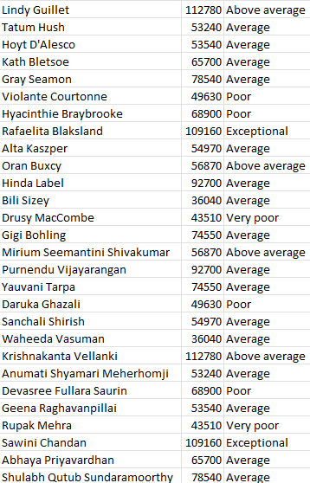

However, we want to sort from highest to lowest salary, so we need to sort the data.
Because the table is now smaller, name=1, salary= 2, rating=3 therefore we want to sort on 2 so it sorts by salary.
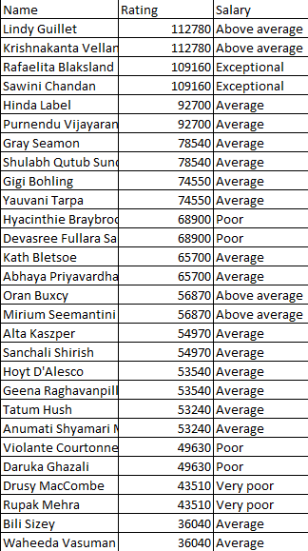

This allows us to always count the number of people in each department so long as we change the value in ‘C5’ and this will also change the table. Aka dynamic

Male vs Female comparison
Creating pivot table, auto sum on age doesn’t help at all
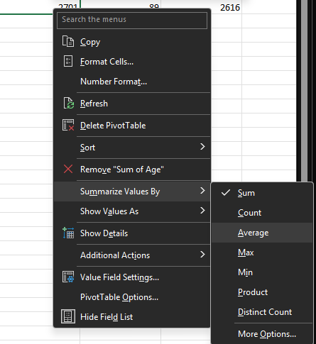

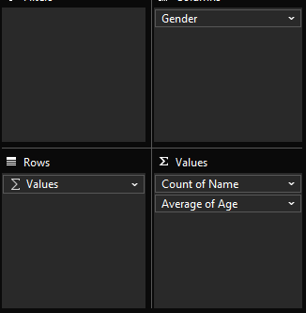
Values in rows allows it to separate each as a row and make it easier to read
Data is skewed due to the ‘other’ gender
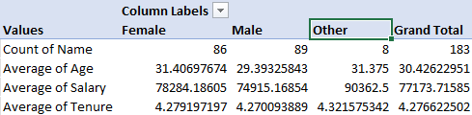
Untick other to get rid of it
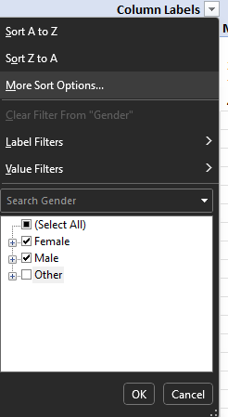

Bonuses:
We want to calculate a bonus for everything, and the bonus works as follows:
If Tenure of more than 2 years, bonus = 3%
If Tenure is less than 2 years, bonus = 2%
Therefore:
In this example we’re rounding to 0 decimal places, so it just comes as a whole number.

Then we want to figure out the top 10 employees bonuses names:
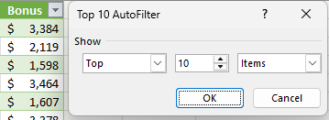
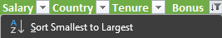
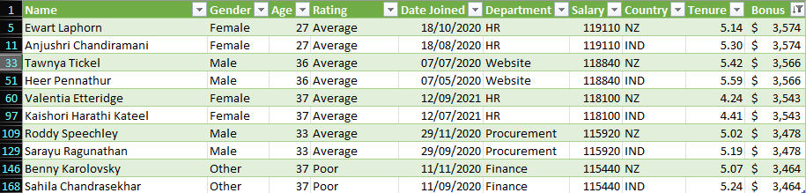
Top 10 employee bonuses

